Core Python
Healthcare Industry
Design a Python class ClinicAppointment that manages patient appointments in a clinic. The system should have the following features: ➔ Book Appointment:
● Prompt for patient name, age, mobile number, and preferred doctor.
● Show time slots (10am, 11am, 12pm, 2pm, 3pm).
● Check slot availability and confirm booking. ➔ View/Cancel Appointment:
● Allow patient to view or cancel their appointment using mobile number. ➔ Doctor Availability:
● Maintain a maximum of 3 appointments per time slot per doctor. ➔ Data Persistence:
● Store appointments in memory only (no files/dbs required)

Ans:
class ClinicAppointment:
def __init__(self):
self.slots = ["10am", "11am", "12pm", "2pm", "3pm"]
self.data = {}
self.doctors = {}

def book(self):
name = input("Name: ")
age = input("Age: ")
mobile = input("Mobile: ")
doctor = input("Doctor name: ")

if mobile in self.data:
print("Already booked")
return

print("Slots:")
for i in range(len(self.slots)):
print(i + 1, self.slots[i])

ch = int(input("Choose slot: ")) - 1

if ch < 0 or ch >= len(self.slots):
print("Wrong slot")
return

slot = self.slots[ch]

if doctor not in self.doctors:
self.doctors[doctor] = {}

if slot not in self.doctors[doctor]:
self.doctors[doctor][slot] = 0

if self.doctors[doctor][slot] == 3:
print("Slot full")
return

self.data[mobile] = [name, age, doctor, slot]
self.doctors[doctor][slot] += 1
print("Booked")

def view(self):
mobile = input("Mobile: ")

if mobile not in self.data:
print("No record")
return

d = self.data[mobile]
print("Name:", d[0])
print("Age:", d[1])
print("Doctor:", d[2])
print("Slot:", d[3])

def cancel(self):
mobile = input("Mobile: ")

if mobile not in self.data:
print("No record")
return

d = self.data[mobile]
self.doctors[d[2]][d[3]] -= 1
del self.data[mobile]
print("Cancelled")

def start(self):
while True:
print("\n1 Book")
print("2 View")
print("3 Cancel")
print("4 Exit")

c = input("Choice: ")

if c == "1":
self.book()
elif c == "2":
self.view()
elif c == "3":
self.cancel()
elif c == "4":
break
else:
print("Wrong choice")

obj = ClinicAppointment()
obj.start()
output:
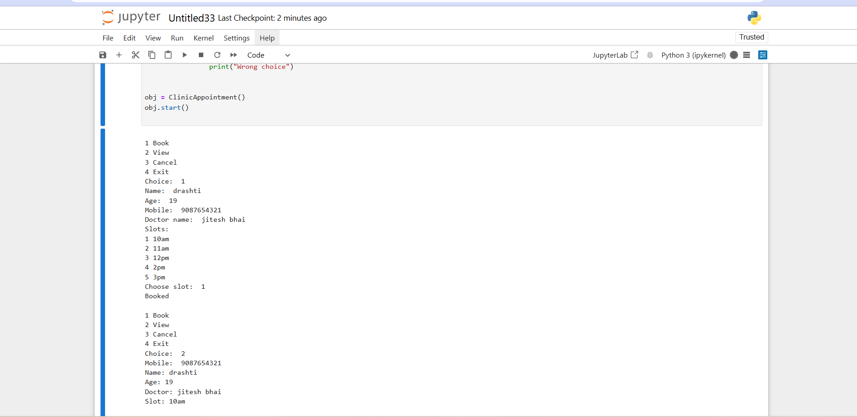
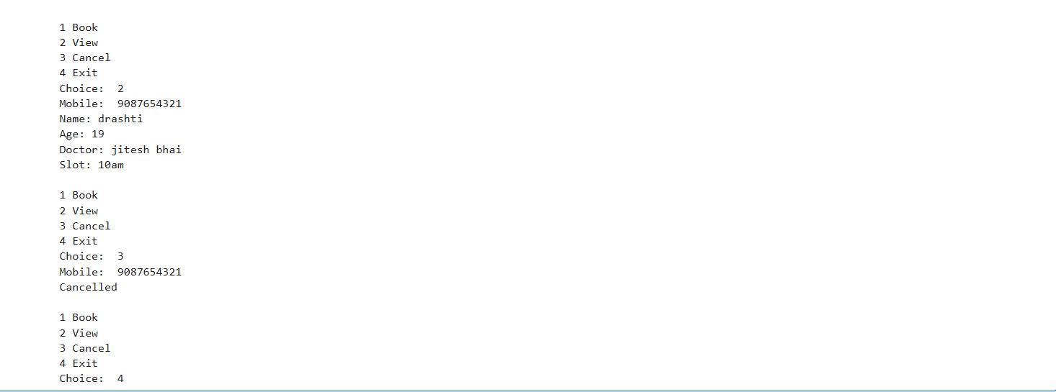

School Management System
Design a Python class SchoolManagement that helps manage student admissions and
records. The system should support:
➔ New Admission:
● Collect student name, age, class (1–12), and guardian's mobile number.
● Assign a unique student ID automatically.
● Validate age: must be between 5 and 18.
● Validate mobile number: must be 10 digits.
➔ View Student Details:
● Allow lookup using student ID.
➔ Update Student Info:
● Update mobile number or class.
➔ Remove Student Record:
● Remove a student using their student ID.
➔ Exit System

ANS:
class SchoolManagement:
def __init__(self):
self.data = {}
self.sid = 1

def add_student(self):
name = input("Enter name: ")
age = int(input("Enter age: "))
cls = int(input("Enter class: "))
mobile = input("Enter mobile: ")

if age < 5 or age > 18:
print("Invalid age")
return

if len(mobile) != 10:
print("Invalid mobile")
return

self.data[self.sid] = [name, age, cls, mobile]
print("Student ID:", self.sid)
self.sid = self.sid + 1

def view_student(self):
i = int(input("Enter student ID: "))
if i not in self.data:
print("Student not found")
return

s = self.data[i]
print("Name:", s[0])
print("Age:", s[1])
print("Class:", s[2])
print("Mobile:", s[3])

def update_student(self):
i = int(input("Enter student ID: "))
if i not in self.data:
print("Student not found")
return

print("1 Update Mobile")
print("2 Update Class")
ch = input("Choice: ")

if ch == "1":
mobile = input("New mobile: ")
if len(mobile) != 10:
print("Invalid mobile")
return
self.data[i][3] = mobile
print("Updated")

elif ch == "2":
cls = int(input("New class: "))
self.data[i][2] = cls
print("Updated")

else:
print("Wrong choice")

def remove_student(self):
i = int(input("Enter student ID: "))
if i in self.data:
del self.data[i]
print("Student removed")
else:
print("Student not found")

def run(self):
while True:
print("\n1 New Admission")
print("2 View Student")
print("3 Update Student")
print("4 Remove Student")
print("5 Exit")

ch = input("Enter choice: ")

if ch == "1":
self.add_student()
elif ch == "2":
self.view_student()
elif ch == "3":
self.update_student()
elif ch == "4":
self.remove_student()
elif ch == "5":
break
else:
print("Wrong choice")

s = SchoolManagement()
s.run()
output:
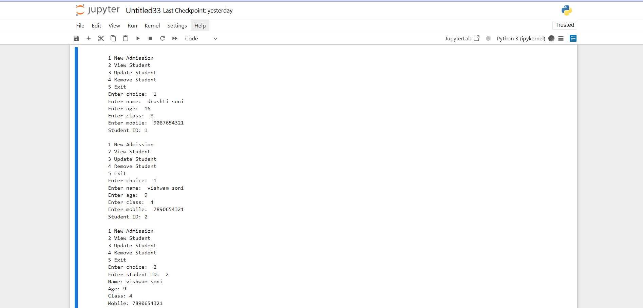
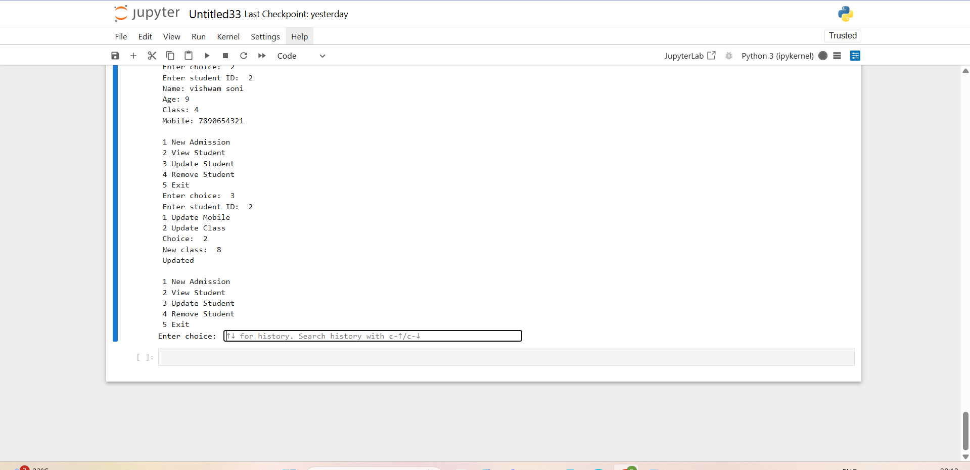
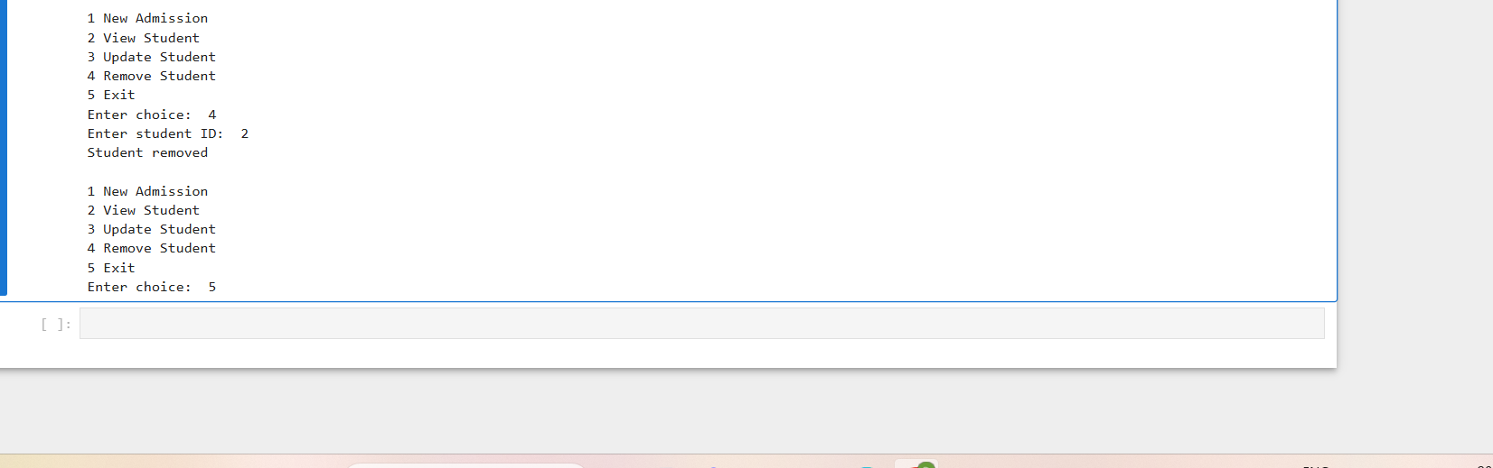
Transport Reservation System (Bus Ticketing)
Design a Python class BusReservation that simulates a basic bus ticket booking system. Features should include:
➔ Show Available Routes: ● Predefined city routes with fixed prices.
● Example: "Mumbai to Pune - ₹500", "Delhi to Jaipur - ₹600", etc. ➔ Book Ticket:
● Enter passenger name, age, mobile, and route.
● Assign seat number (max 40 per bus per route).
● Generate a unique ticket ID. ➔ View Ticket:
● Lookup using ticket ID. ➔ Cancel Ticket:
● Cancel the ticket if it exists. ➔ Exit

Ans:
class BusReservation:
def __init__(self):
self.routes = {
1: ["Mumbai to Pune", 500],
2: ["Delhi to Jaipur", 600],
3: ["Ahmedabad to Surat", 400]
}
self.tickets = {}
self.seat_count = {}
self.tid = 1

def show_routes(self):
print("\nAvailable Routes:")
for i in self.routes:
print(i, self.routes[i][0], "-", self.routes[i][1])

def book_ticket(self):
name = input("Enter name: ")
age = input("Enter age: ")
mobile = input("Enter mobile: ")

self.show_routes()
r = input("Select route number: ")

if not r.isdigit():
print("Invalid route")
return

r = int(r)

if r not in self.routes:
print("Invalid route")
return

if r not in self.seat_count:
self.seat_count[r] = 0

if self.seat_count[r] >= 40:
print("Bus full")
return

self.seat_count[r] = self.seat_count[r] + 1
seat = self.seat_count[r]

self.tickets[self.tid] = [name, age, mobile, r, seat]
print("Ticket booked")
print("Ticket ID:", self.tid)
print("Seat No:", seat)
self.tid = self.tid + 1

def view_ticket(self):
i = input("Enter ticket ID: ")

if not i.isdigit():
print("Invalid ID")
return

i = int(i)

if i not in self.tickets:
print("Ticket not found")
return

t = self.tickets[i]
print("Name:", t[0])
print("Age:", t[1])
print("Mobile:", t[2])
print("Route:", self.routes[t[3]][0])
print("Price:", self.routes[t[3]][1])
print("Seat:", t[4])

def cancel_ticket(self):
i = input("Enter ticket ID: ")

if not i.isdigit():
print("Invalid ID")
return

i = int(i)

if i in self.tickets:
del self.tickets[i]
print("Ticket cancelled")
else:
print("Ticket not found")

def run(self):
while True:
print("\n1 Show Routes")
print("2 Book Ticket")
print("3 View Ticket")
print("4 Cancel Ticket")
print("5 Exit")

ch = input("Enter choice: ")

if ch == "1":
self.show_routes()
elif ch == "2":
self.book_ticket()
elif ch == "3":
self.view_ticket()
elif ch == "4":
self.cancel_ticket()
elif ch == "5":
break
else:
print("Wrong choice")

b = BusReservation()
b.run()

output:

